# Selenium Basics

**Introduction**: Selenium is a free (open source) automated testing suite for web applications across different browsers and platforms. It is quite similar to HP Quick Test Pro (QTP now UFT) only that Selenium focuses on automating web-based applications. Testing done using Selenium tool is usually referred as Selenium Testing.

Selenium is not just a single tool but a suite of software's, each catering to different testing needs of an organization. **It has four components:**

* Selenium Integrated Development Environment (IDE)
* Selenium Remote Control (RC)
* WebDriver
* Selenium Grid

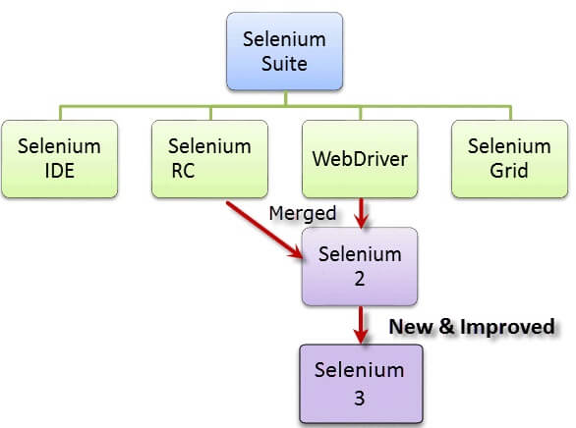

At the moment, Selenium RC and WebDriver are merged into a single framework to form **Selenium 2**. Selenium 1, by the way, refers to Selenium RC.

1. **Selenium IDE (Integrated Development Environment)**:  It is the simplest tool in the Selenium Suite. It is a Firefox add-on that creates tests very quickly through its record-and-playback functionality. This feature is similar to that of QTP. It is effortless to install and easy to learn. Because of its simplicity, Selenium IDE should only be used as a prototyping tool, not an overall solution for developing and maintaining complex test suites.

Selenium IDE supports autocomplete mode when creating tests. This feature serves **two purposes**:

* It helps the tester to enter commands more quickly.
* It restricts the user from entering invalid commands

**Features of Selenium IDE:**

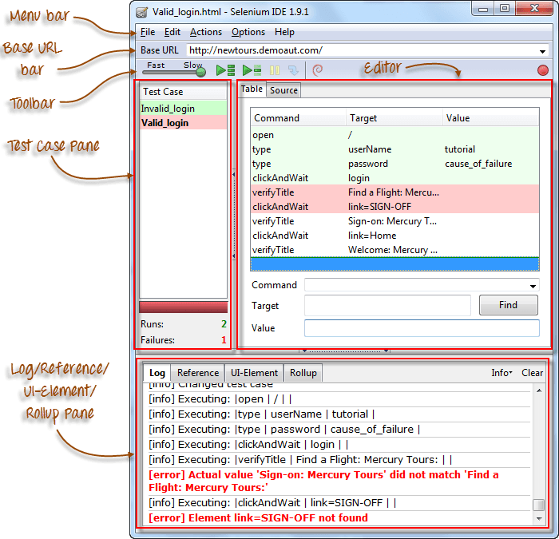

## Menu Bar

* It is located at the **top most portion** of the IDE. The most commonly used menus are the **File**, **Edit**, and **Options** menus. It is used in creating, modifying, and exporting test cases into formats useable by Selenium RC and WebDriver.

## Base URL Bar

[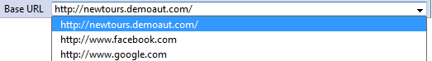](https://www.guru99.com/images/BaseURL.png)

* It has **a dropdown menu that** **remembers all previous values** for easy access.
* The Selenese command **"open" will take you to the URL that you specified in the Base URL**.

## Toolbar

|  |  |
| --- | --- |
| [Introduction to Selenium IDE](https://www.guru99.com/images/fast-slow.png) | **Playback Speed**. This controls the speed of your Test Script Execution. |
| [Introduction to Selenium IDE](https://www.guru99.com/images/record.png) | **Record.**This starts/ends your recording session.  Each browser action is entered as a Selenese command in the Editor. |
| [Introduction to Selenium IDE](https://www.guru99.com/images/play_entire_test_suite.png) | **Play entire test suite**. This will sequentially play all the test cases listed in the [TestCase](https://www.guru99.com/test-case.html)Pane. |
| [Introduction to Selenium IDE](https://www.guru99.com/images/play_current_test_case.png) | **Play current test case**. This will play only the currently selected test case in the Test Case Pane. |
| [Introduction to Selenium IDE](https://www.guru99.com/images/pause_resume_2.png) | **Pause/Resume**. This will pause or resume your playback. |
| [Introduction to Selenium IDE](https://www.guru99.com/images/step.png) | **Step**. This button will allow you to step into each command in your test script. |
| [Introduction to Selenium IDE](https://www.guru99.com/images/rollup_button.png) | **Apply rollup rules**. This is an advanced functionality. It allows you to group Selenese commands together and execute them as a single action. |

## Test Case Pane

|  |  |
| --- | --- |
| [Introduction to Selenium IDE](https://www.guru99.com/images/test_case_pane_-_final.png) | * **The Test Case Pane shows the list of currently opened test cases.** * When we open a test suite, the test case pane will **automatically list all the test cases** contained in it. * The test case written in **bold font** is the **currently selected test case** * After playback, **each test case is color-coded** to represent if it passed or failed.   + Green color means "Passed."   + Red color means "Failed." |

## Editor

* **The place where all the action happens**. The **Editor** provides the **interface for your test scripts**. It is available in two views: **Table** and **Source**.

##### **Table** **View**

* Most of the time, you will work on Selenium IDE using the **Table View**.
* This is **where you create and modify Selenese commands.**
* After playback, each step is color-coded.

[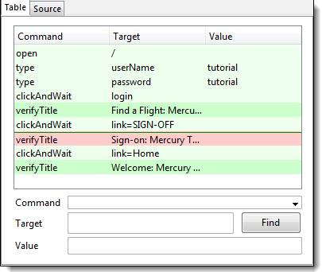](https://www.guru99.com/images/Editor.png)

* To create steps, type the name of the command in the "Command" text box.
* **It displays a dropdown list of commands**that match with the entry that you are currently typing.
* Target is any parameter (like username, password) for a command and Value is the input value (like tom, 123pass) for those Targets.

[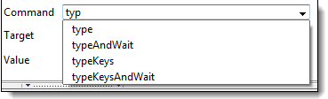](https://www.guru99.com/images/TableEditor.png)

##### **Source** **View**

* It displays the steps in HTML (default) format.
* It also allows you to edit your script just like in the Table View.

[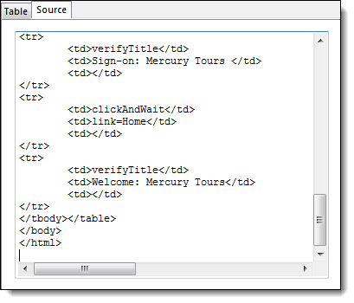](https://www.guru99.com/images/editor_source_-_final.png)

## Log Pane

**The Log Pane displays runtime messages**during execution. It provides real-time updates as to what Selenium IDE is doing.

**Logs are categorized into four types:**

* **Debug** - By default, Debug messages are not displayed in the log panel. They show up only when you filter them. They provide technical information about what Selenium IDE is doing behind the scenes. It may display messages such as a specific module has done loading, a certain function is called, or an external JavaScript file was loaded as an extension.
* **Info** - It says which command Selenium IDE is currently executing.
* **Warn** - These are warning messages that are encountered in special situations.
* **Error** - These are error messages generated when Selenium IDE fails to execute a command, or if a condition specified by "verify" or "assert" command is not met.

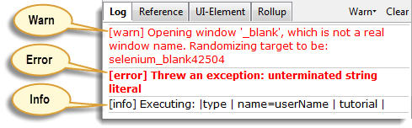

**Logs can be filtered by type**. For example, if we choose to select the "Error" option from the dropdown list, the Log Pane will show error messages only.

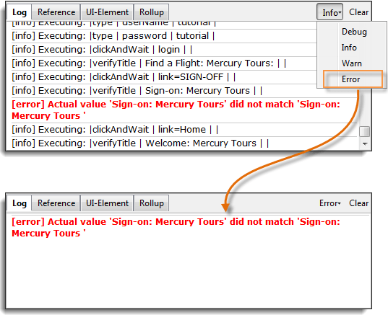

## Reference Pane

The Reference Pane shows a concise description of the currently asked Selenese command in the Editor. It also shows the description about the locator and value to be used on that command.

[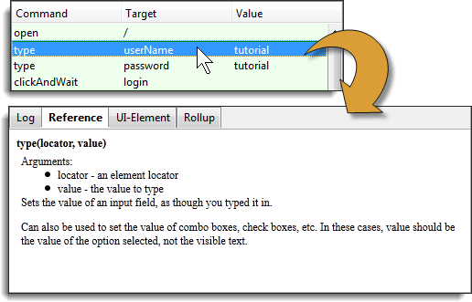](https://www.guru99.com/images/complete.png)

## UI-Element

The UI-Element is for advanced Selenium users. It uses **JavaScript Object Notation(JSON)** to define element mappings. The documentation and resources are found in the “UI Element Documentation” option under the Help Menu of Selenium IDE.

[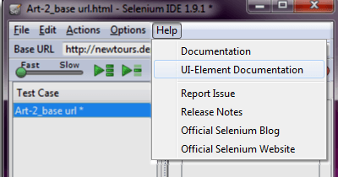](https://www.guru99.com/images/Help.png)

**An example of a UI-element screen is shown below**.

[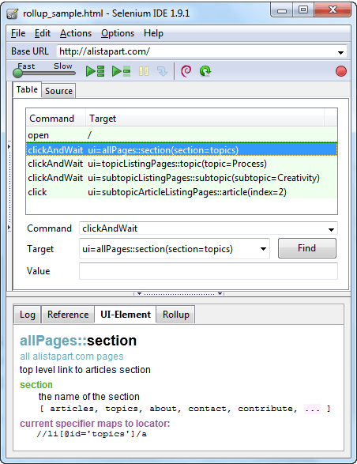](https://www.guru99.com/images/ide_screenshot.png)

**Roll Up**

**Rollup allows us to execute a group of commands in one step. A group of commands is simply called as a “rollup”. It employs heavy use of JavaScript and UI-Element concepts to formulae a collection of commands that is similar to a “function” in programming languages.**

**Rollups are reusable; meaning, they can be used multiple times within the test case. Since rollups are groups of commands condensed into one, they contribute a lot in shortening our test script.**

[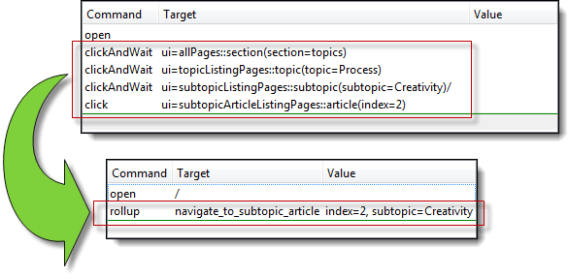](https://www.guru99.com/images/rollup_condensed.png)

**An example of how the contents of the rollup tab look like is shown below**

. [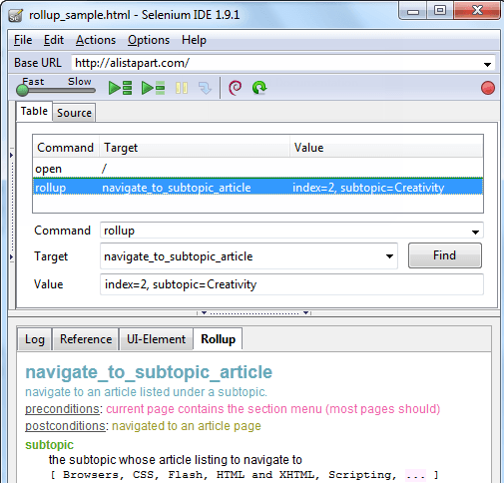](https://www.guru99.com/images/rollup.png)